BASH SCRIPTING TASK – 02

- create a bash script to check if a directory is available or not.
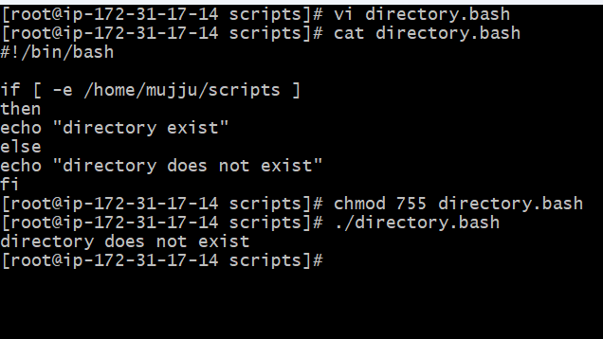

2.Create a bash script to create multiple files.

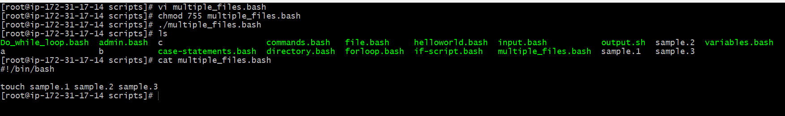

3.Create a bash script to take a backup of a directory.

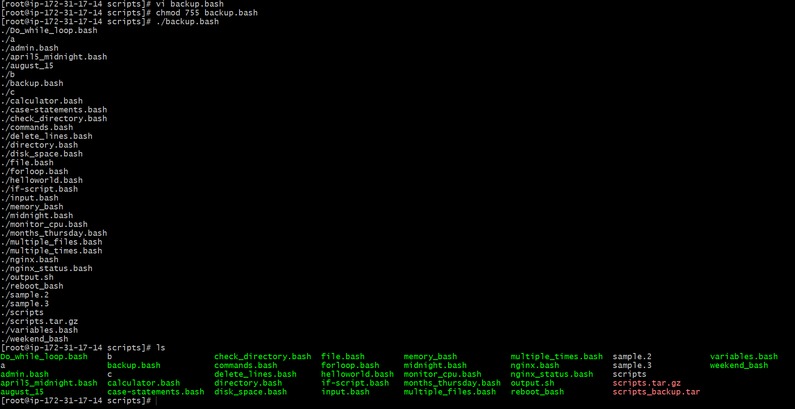

4.Create a bash script to install Nginx on an EC2 server
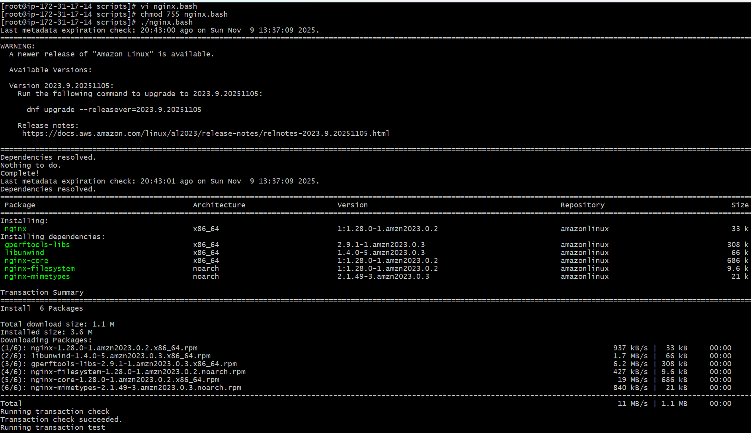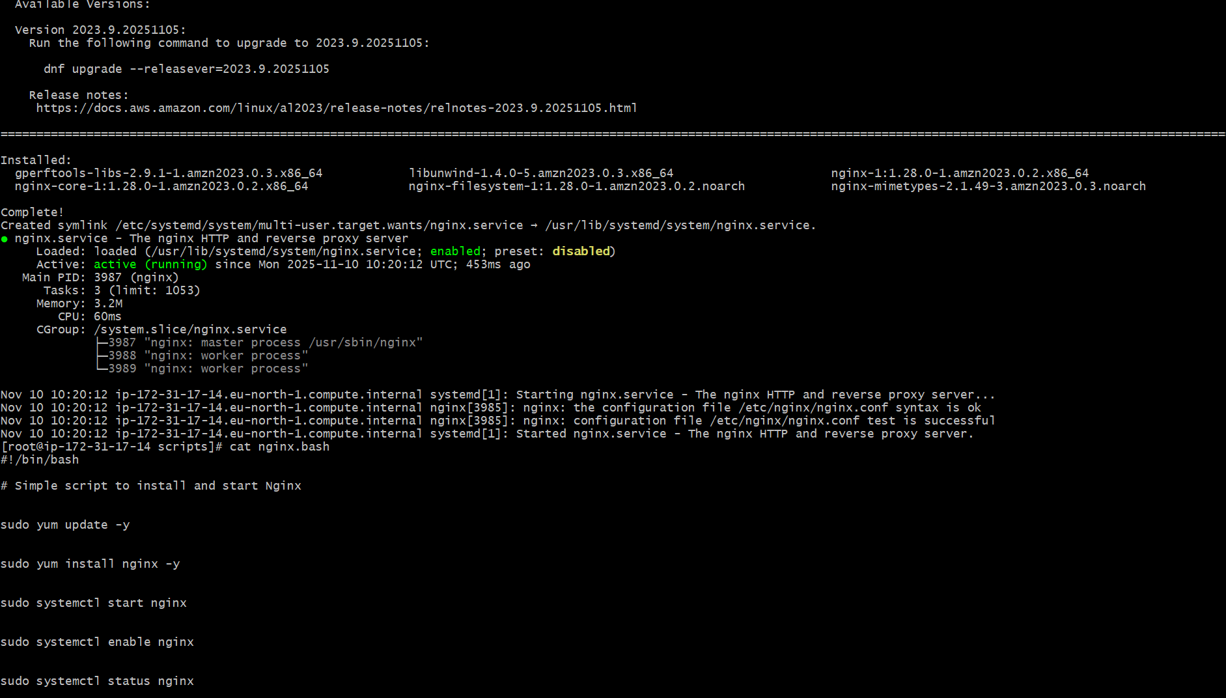

6.Create a bash script to check if the Nginx service is running, if not running then script should start the service.

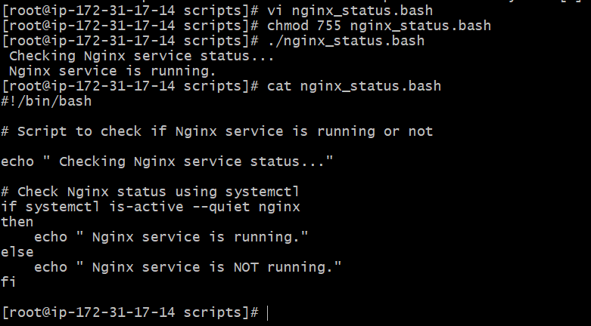

7.Create a bash script for a calculator
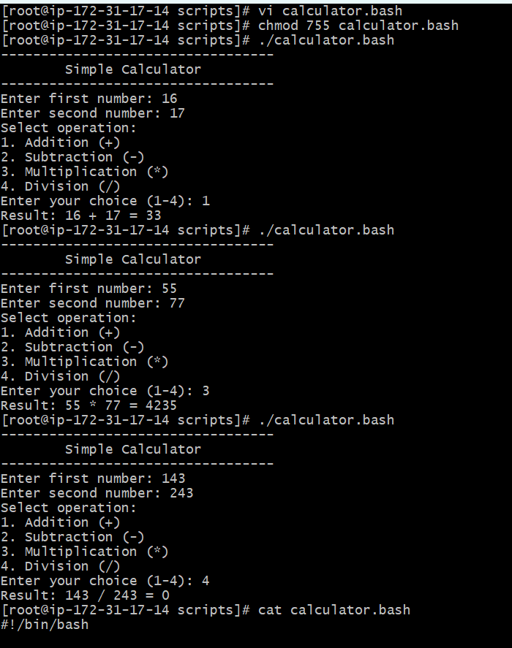

8.Create a bash script to check if a directory exists, if not then create a directory.

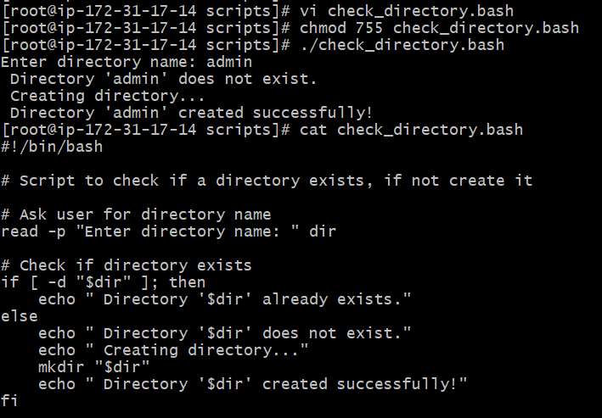

9.Create a bash script to delete the last 3 lines of a file.
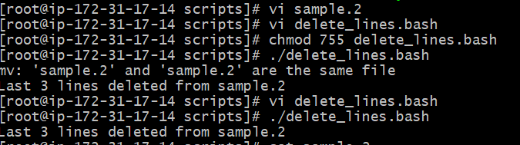

10.Bash script to monitor cpu and if it is more than 80% then send email notification.

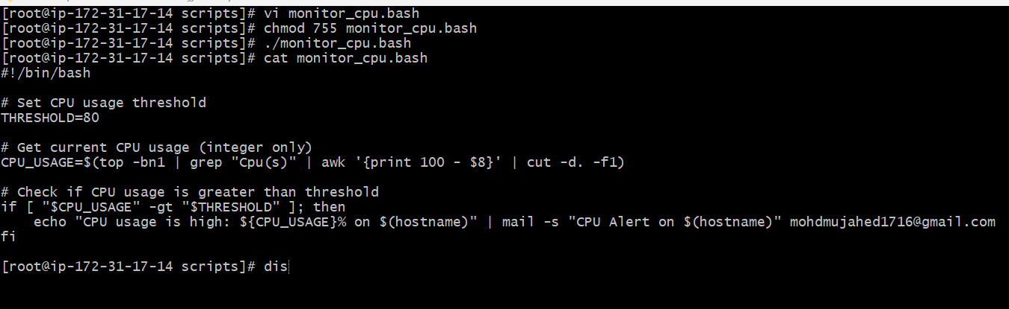

11.Bash script to monitor disk space and if it is more than 80% then send email notification.
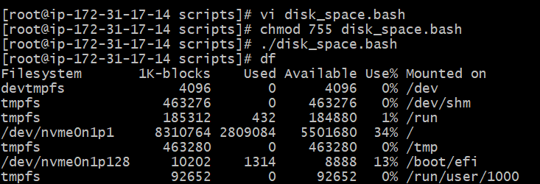
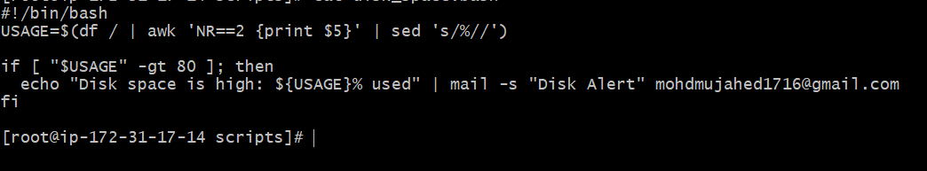

12.Bash script to monitor memory and if it is more than 80% then send email notification.
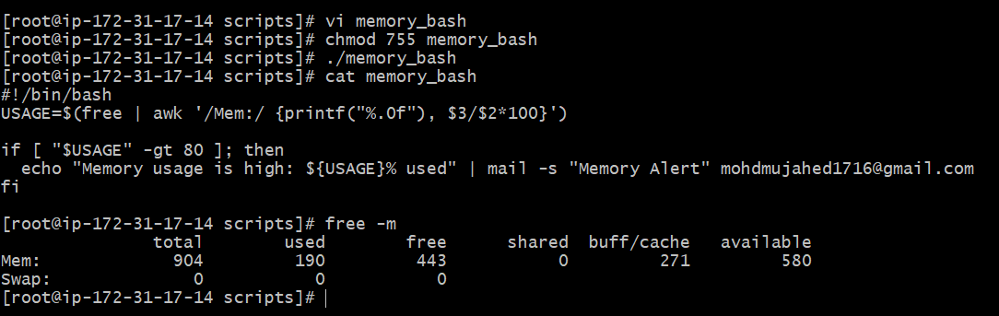

Crontab exercises:
- April 5th Midnight

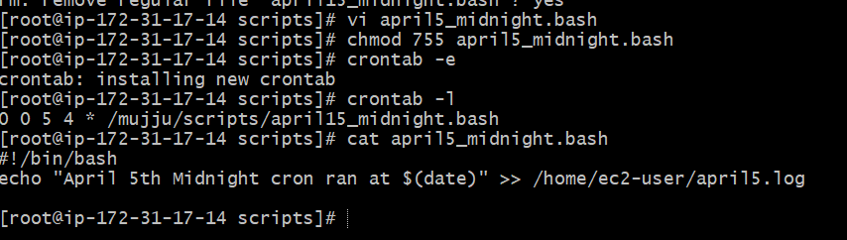

- 5th of Every November, January, June if it is a Thursday

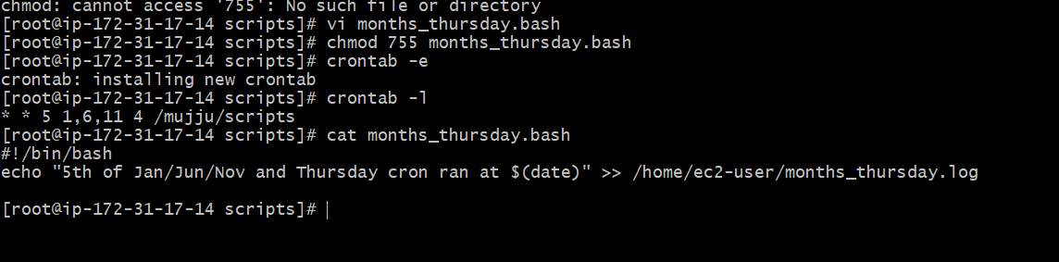

- At 05 and 27th minutes of 9, 10, 11 hours every day

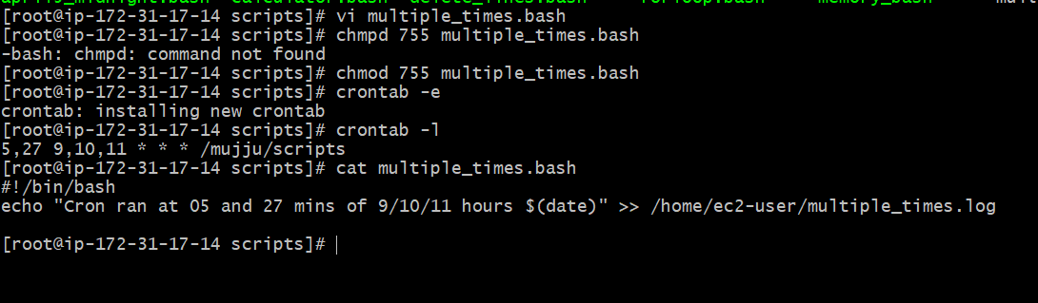

- 34 minutes of 9th hour on 15th August
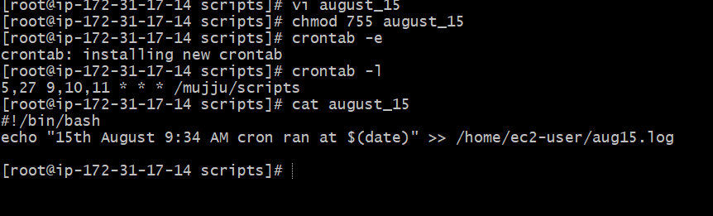

- Every Midnight
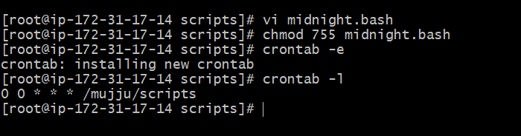

- Every Weekend (Saturday night 11:59 PM)

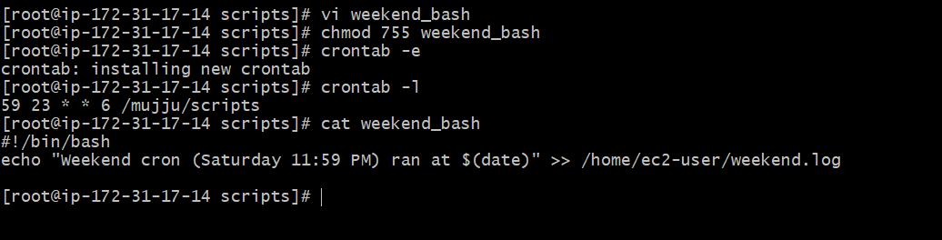
- After every reboot

